Flow file upload
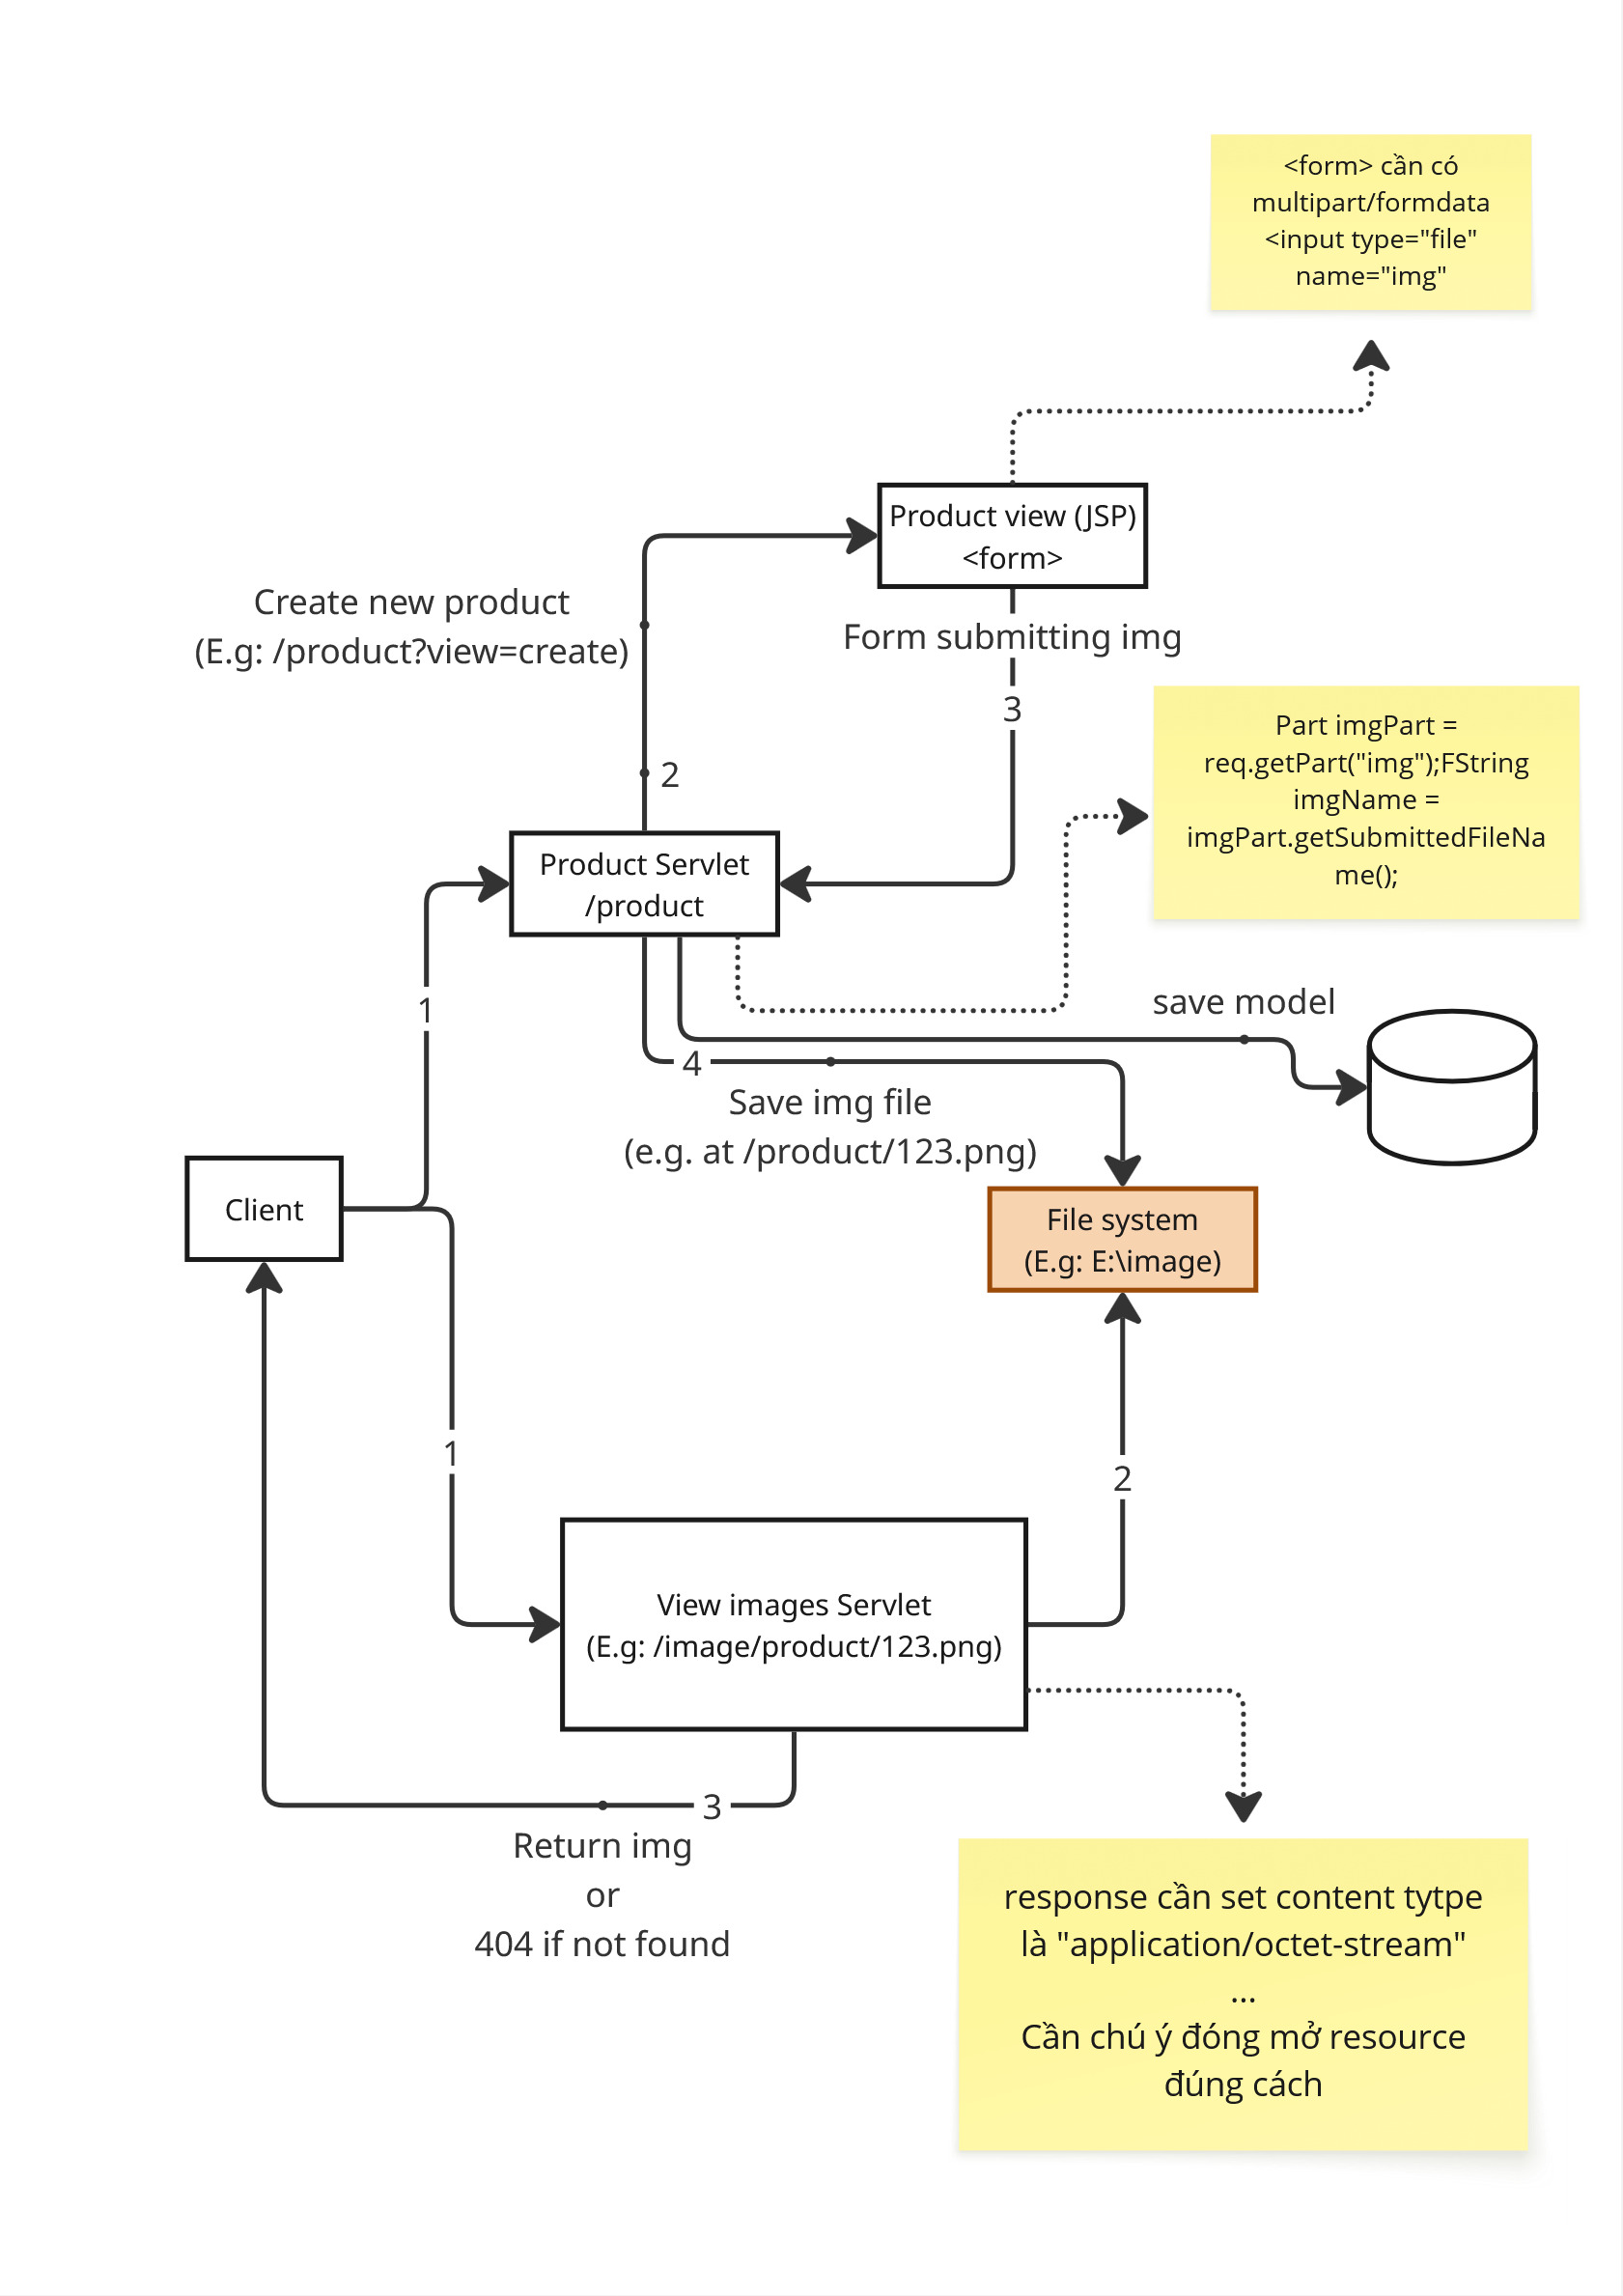
## Show the img (need a servlet with /image)
```Java
@WebServlet(name = "ImageController", urlPatterns = {"/image/*"})
public class ImageController extends HttpServlet {
protected void doGet(HttpServletRequest request, HttpServletResponse response)
throws ServletException, IOException {
String pathInfo = request.getPathInfo();
System.out.println(pathInfo);
if (pathInfo == null || pathInfo.equals("/")) {
response.sendError(HttpServletResponse.SC_NOT_FOUND);
return;
}
File file = new File(FileUpload.UPLOAD_DIR + pathInfo);
if (!file.exists()) {
response.sendError(HttpServletResponse.SC_NOT_FOUND);
return;
}
String mimeType = getServletContext().getMimeType(file.getName());
response.setContentType(mimeType != null ? mimeType : "application/octet-stream");
response.setContentLength((int) file.length());
try (InputStream in = new FileInputStream(file);
OutputStream out = response.getOutputStream()) {
byte[] buffer = new byte[1024];
int bytesRead;
while ((bytesRead = in.read(buffer)) != -1) {
out.write(buffer, 0, bytesRead);
}
}
}
}
```

